**AstroSage Analysis**

**Spreadsheet Project**

**Objective and Subjective Questions**

**Prepared by : LAKSHYA HASIJA**

Course : Professional Certificate Course In Data Science - May 2025

**Introduction**

This document presents an analysis of data sourced from AstroSage, conducted using Microsoft Excel. The objective of this analysis is to uncover meaningful insights based on a predefined set of questions. Using various Excel functions and tools.

The findings are organized and interpreted in direct response to the questions provided, offering a clear and data-backed overview of the results. This analysis aims to support informed decision-making and deeper understanding of the underlying dataset.

**Objective Questions**

1. What is the total no. of tables present in the data?

**Answer –** A table is the collaboration of rows and columns. We have **only 1 table namely ‘Astrosage_Analysis’** present in the ‘Cleaned Data’ Sheet.

1. Reference = Sheet: **Cleaned_Data.**
2. KeyInsights **=** Only **one structured table** named **“AstroSage_Analysis”** is present which is located in the **“CLEANED_DATA”** sheet.

Kindly refer the image also attached below.

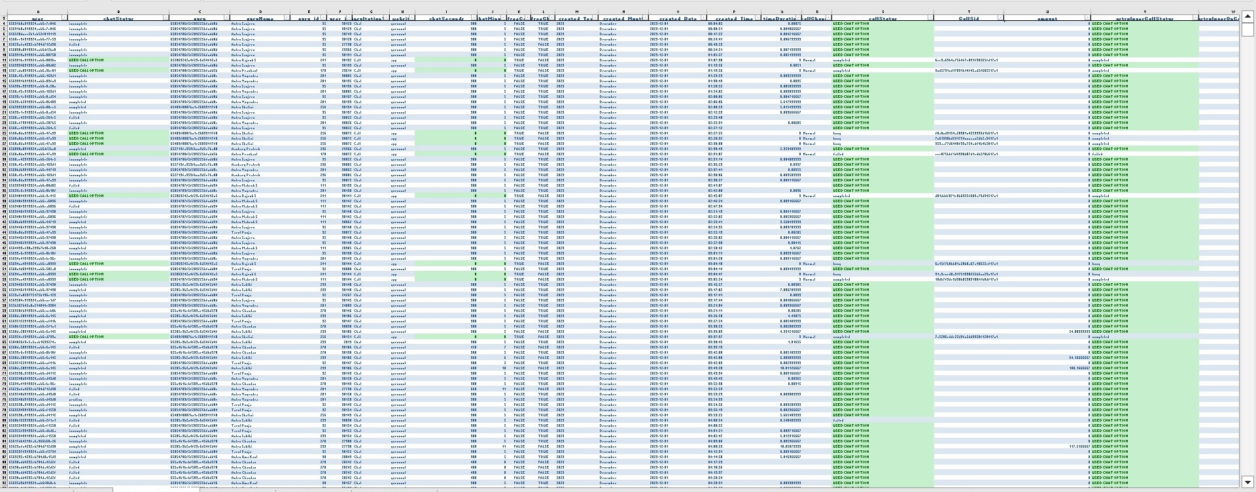

1. What is the total no. of attributes present in the data?

**Answer –** There are total 37 attributes (columns) in the ‘Cleaned Data’ Sheet.

1. ApproachUsed **=** Counted columns from Column A to Column AK.
2. **Key Insights =** Total **37 attributes (columns)** identified in the cleaned dataset being verified visually via screenshots in the document.

Kindly refer the image also attached below.

Image 1 – Column A to Column J

Image 2 – Column K to Column T

Image 3 – Column U to Column AA

Image 4 – Column AB to Column AK









1. The data consists of some inconsistent and missing values so ensure that the data used for further analysis is cleaned.

**Answer –** The Project was assigned as a ‘Raw Data’ Sheet with many missing values in most of the columns. Thus , the sheet was cleaned by many ways.

Such as:

1. Firstly , I copied the raw data into a new sheet named as **“CLEANED DATA”**
2. Named the whole table from **’TABLE1’** to **“AstroSage_Anaylsis”.**

Key Insights

* A systematic cleaning process was followed.
* Data now fully prepared for further analysis.
* All missing/inconsistent values were accounted for.
* Logical formulas were applied to extract and standardize data.

1. Then all the unwanted columns were deleted like
   * Column **‘_id’**
   * Column **‘refundStatus’**
   * Column **‘isWhiteListUser’**
   * Column **‘queue’**
   * Column **‘updatedAt’**
   * Column **‘__v’**
   * Column **‘statementEntryId’**
   * Column **‘chatStartTime’**
   * Column **‘chatEndTime’**
   * Column **‘callIvrType’**
2. **created_Year** column was extracted from “createdAT”.
   * Formula being used = **TEXT(data!P2, "YYYY")**
3. **created_Month** column was extracted from “createdAT”.
   * Formula being used = **TEXT(data!P2, "MMMM")**
4. **created_Date** column was extracted from “createdAT”.
   * Formula being used = **TEXT(data!P2, "YYYY-mm-dd")**
5. **created_Time** column was extracted from “createdAT”.
   * Formula being used = **TIME(HOUR(data!P2),MINUTE(data!P2),SECOND(data!P2))**
6. **created_Hour** column was extracted from “created_Time”.
   * Formula being used = **Hour(P$4)**
7. **timeDuration** column was showing values in wrong format. Thus **FORMATTED THE COLUMN IN hh:mm:ss STYLE**
8. Blank spaces in **chatStatus** were filled with the Formula being used = **IF(ISBLANK(data!C2), "USED CALL OPTION", data!C2)** and those cells are highlighted with green shade.
9. Blank spaces in **chatSeconds** were filled with the Formula being used = **IF(ISBLANK(data!L2), 0, data!L2)** and those cells are highlighted with green shade.
10. Later on chat seconds were converted to chat minutes with Formula being used = **I4/60**
11. Names of GURUS in **guruName** was corrected with the Formula being used = **PROPER(TRIM(data!E2))**
12. Blank spaces in **callStatus** were filled with the Formula being used = **IF(ISBLANK(data!Y2), "USED CHAT OPTION", data!Y2)** and those cells are highlighted with green shade.
13. Blank spaces in **amount** were filled with the Formula being used = **IF(ISBLANK(Cleaned_Data!AA2), 0, data!AA2)**.
14. Blank spaces in **astrologerCallStatus** were filled with the Formula being used = **IF(ISBLANK(data!AB2), "USED CHAT OPTION", data!AB2)** and those cells are highlighted with green shade.
15. Blank spaces in **astrologerOnCallDuration** were filled with the Formula being used = **IF(ISBLANK(data!AC2), 0, data!AC2)**
16. Later on astrologerOnCallDuration seonds were converted to astrologerOnCallDuration(MINUTES) with Formula being used = **X4/60**
17. Blank spaces in **astrologersEarnings** were filled with the Formula being used = **IF(ISBLANK(data!AD2), 0, data!AD2)**
18. Blank spaces in **netAmount** were filled with the Formula being used = **IF(ISBLANK(data!AE2), 0, data!AE2)**
19. Blank spaces in **region** were filled with the Formula being used = **IF(ISBLANK(data!AF2), "UNKNOWN", data!AF2)** and those cells WHICH HAVE INDIAN are highlighted with green shade.
20. Blank spaces in **userCallStatus** were filled with the Formula being used = **IF(ISBLANK(data!AG2), "USED CHAT OPTION", data!AG2)** and those cells are highlighted with green shade.
21. Blank spaces in **userOnCallDuration** were filled with the Formula being used = **IF(ISBLANK(data!AH2), 0, data!AH2)**
22. Later on userOnCallDuration seconds were converted to userOnCallDuration(MINUTES) with Formula being used = **AD4/60**
23. At the last I created 3 new columns namely :
    * **“repeatedUser based on User_Id”** (Formula being used = **COUNTIF(data!$G$2:$G$28030, data!G2)** )
    * **“repeatedCalls”** (Formula being used = **COUNTIFS(data!$H$2:$H$28030, "Call", data!$G$2:$G$28030, data!G2)** )
    * **“repeatedChats”** (Formula being used = **AF4-AG4** )
24. Also , I used the formula of **UNIQUE(D4:D28030)** to determine **Unique guruName** and pasted them in a new column namely **Unique_guruName**
25. And at last used the formula of **COUNT(unique(data!F2:F28028))** to calculate Actual Count of Gurus based on their guru_id. And the count was **131**
26. The last step I did was that I wrote all the formulas in the 1st row of each column where formula is being used to determine the values. And highlighted them with **ORANGE , ACCENT 6 , LIGHTER 40%** shade from FONT OPTION in HOME RIBBON.

Hence , this was the process I followed to clean the data.

The whole cleaned data is in a separate sheet named as **‘CLEANED DATA’ sheet** in the EXCEL FILE named as **“AstroSage_analysis_BY_LakshyaHasija”.**

1. What is the change in daily call volume day by day and also find the average daily call volume.

**Answer –**

1. Approach Used
   1. Created a daily call volume table.
   2. Used AVERAGE() function to find average call volume.
2. **Key Insights**
   1. **Average Daily Call Volume = 246.03**
   2. Visualized change in call volume over time.

**Average Daily Call Volume = 246.0294118**

**FORMULA = AVERAGE(C7:C40)**

Kindly refer the image attached below.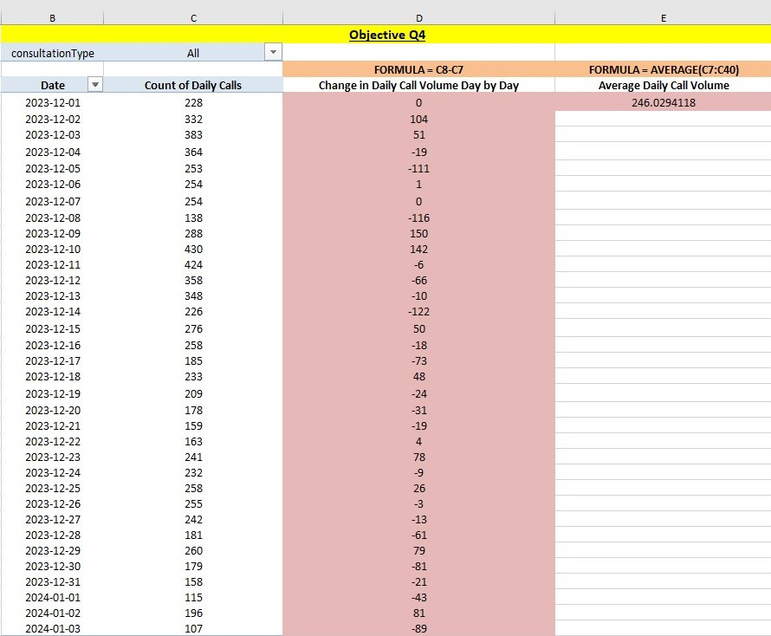

1. Which months experienced the highest and lowest call volumes?

**Answer –** Highest month is **DECEMBER** with 7947 calls and Lowest month is **JANUARY** with 418 calls.

1. Approach Used
   1. Grouped data by created_Month
   2. Counted call entries per month
2. Key Insights
   1. **Highest** call volume: **December** (7947 calls)
   2. **Lowest** call volume: **January** (418 calls)
3. Suggestions
   1. Investigate why January's call volume dropped.
   2. Use this trend to plan seasonal promotions or staffing.

Kindly refer the image also attached below.

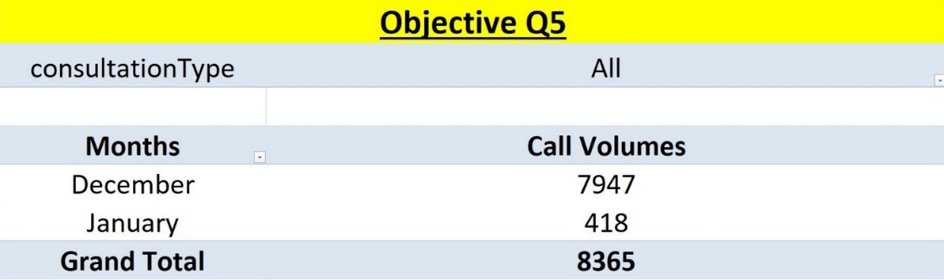

1. What is the total operational cost for that month?

**Answer –** Total Operational Cost for both the months is calculated from astrologersEarnings column.

**Total Operational Cost based on astrologerEarnings for December month is 93786.16295 and for January month is 5360.408**

1. Approach Used
   1. Filtered data by month and summed astrologersEarnings
2. Insights
   1. December: ₹93,786.16
   2. January: ₹5,360.41
3. Suggestions
   1. Budget planning should consider monthly variations

Kindly refer the image also attached below.

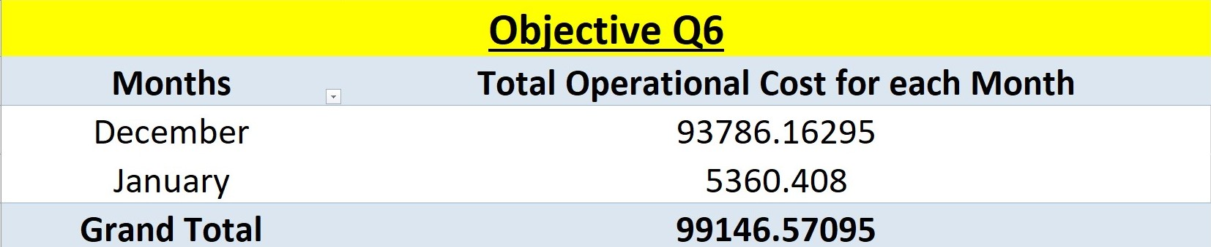

1. What is the average number of calls handled per agent per day?

**Answer –**

1. Reference = Sheet with call and agent totals
2. Approach Used = L12/(L16*L20)
3. Insights = Average per agent per day = 1.8776
4. Suggestions = Increase agent efficiency to improve this ratio

**Average no. of calls handled per agent per day = 1.877638078**

**FORMULA =L12/(L16*L20)**

Kindly refer the image also attached below.

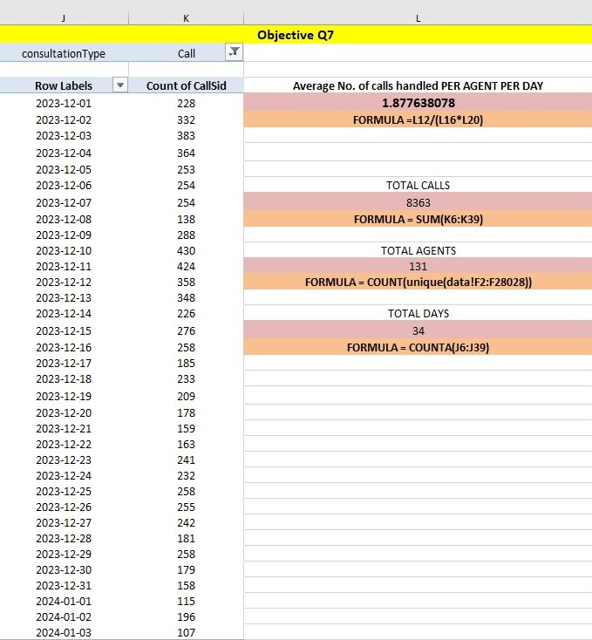

1. How many repeat callers are there, and what percentage of total calls do they represent?

**Answer –**

A. Approach Used

1. Created a Pivot Table grouped by User ID and counted the number of CallSid entries per user.
2. Applied a filter to include only "CALL" entries under Consultation Type.
3. Used the following formulas:

* Step 1: Total Callers = Count of total callers using the count of User ID.  
  Formula used = **COUNT(N6:N3633)**  
  Answer = **3628**
* Step 2: Single Callers = Calculation of the no. of users who called only once , using COUNTIF() function , with the condition to count users who have exactly one call.  
  Formula = **COUNTIF(O6:O3633, "1")**  
  Answer = **2353**. (2353 users are those who called only once during the given period.)
* Step 3: Repeated Callers = Calculation of the no. of repeated callers by using COUNTIF() function , with the condition to count users who have made more than one call.  
  Formula = **COUNTIF(O6:O3633, ">1")**

Answer = **1275**. (1,276 users who called more than once.)

* Step 4: Total Calls = Count of total calls using the sum of CallSid.

Formula = **SUM(O6:O3633)**

Answer = **8365**

* Step 5: Single Calls = Calculation of single calls done only once , using SUMIF() function , with the condition who having exactly one call.  
  Formula = **SUMIF(O6:O3633, "1", O6:O3633)**

Answer = **2353**. (2353 are the total calls done only once during the given period.)

* Step 6: Repeated Calls = Calculation of repeated calls done by using SUMIF() function , with the condition of having more than one call.  
  Formula = **SUMIF(O6:O3633, ">1", O6:O3633)**

Answer = **6012**. (1276 are the total repeated calls made more than once.)

* Step 7: EXACT Repeated Calls EXCEPT THE 1st CALL:

Formula = **REPEATED CALLS (Q12)– REPEATED CALLS** (**Q8) –– (Q12-Q8)**

Answer = **4737**

* Step 8: Finding the Percentages
  + **Repeated Calls (%)** = PERCENTAGE OF Repeated Call

Formula = (Exact Repeated Calls / Total Calls) * 100

Answer = (4737 / 8365) * 100 = 56.62881052.

**(CONVERTED TO PERCENTAGE FORM = 56.63% of the total calls were made by users who called more than once.)**

* + **Repeated Callers (%)** = PERCENTAGE OF Repeated Callers  
    Formula: (Repeated Callers / Total Callers) * 100   
    = (1275 / 3628) * 100 = 35.14332966.

**(CONVERTED TO PERCENTAGE FORM = 35.14%)**

* So, 35.14% of the callers are Repeated Callers and they contribute to 56.63% of the Total Calls.

B. Insights

* **Total Callers:** =COUNT(N6:N3633) → 3628 users
* **Single Callers:** =COUNTIF(O6:O3633, "1")→ 2353 users
* **Repeat Callers:** =COUNTIF(O6:O3633, ">1") → 1275 users
* **Total Calls**: =SUM(O6:O3633) → 8365 calls
* **Single Calls:** =SUMIF(O6:O3633, "1", O6:O3633) → 2353 calls
* **Repeated Calls:** = SUMIF(O6:O3633, ">1", O6:O3633)) → 6012 calls
* **EXACT Repeated Calls EXCEPT THE 1st CALL:** = 6012 – 1275 = 4737

1. Out of 3628 total callers, 1275 callers (35.14%) made more than one call.
2. Repeated callers contributed to 6012 of the total 8365 calls (71.87%).
3. 4737 calls were repeated interactions (beyond the first call).
4. 56.63% of total calls were repeated calls, showing a significant portion of users required multiple interactions.

C. Suggestions

1. Consider analyzing the reasons behind multiple calls—are users not satisfied in the first interaction?
2. Improve first-call resolution rates to reduce repeat calls and enhance efficiency.
3. Segment repeat callers to offer proactive follow-ups or support, possibly reducing unnecessary call volume over time.

Kindly refer the image also attached below.

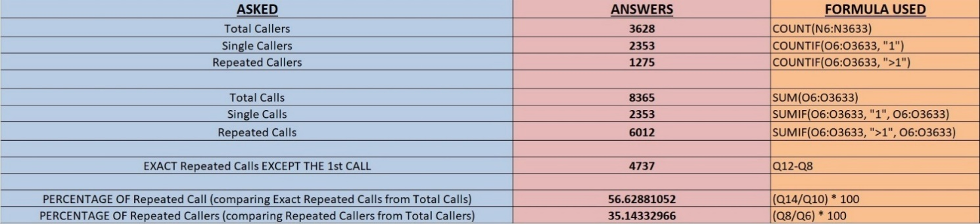

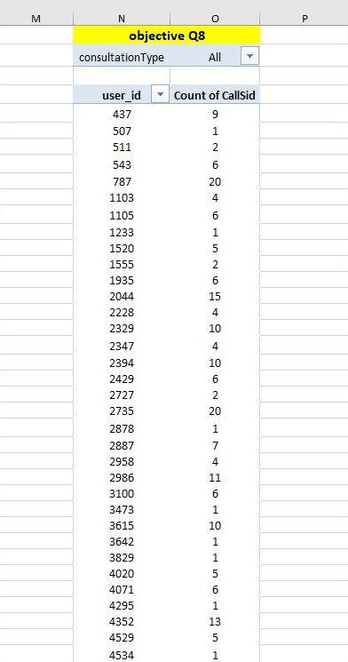

1. What are the total sales generated by the call centre for each product category?

**Answer –** Kindly refer the image attached below.

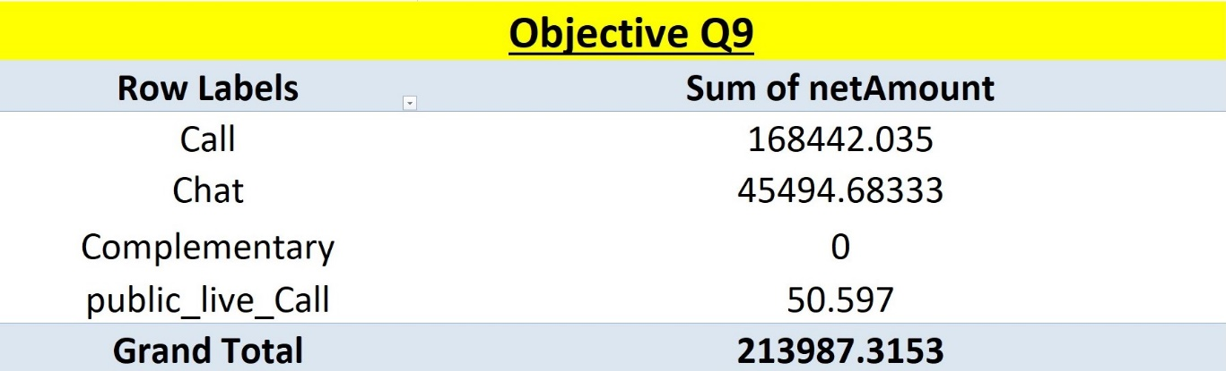

1. How many calls were made for each user ID and guru ID?

**Answer –** Kindly refer the image attached below.

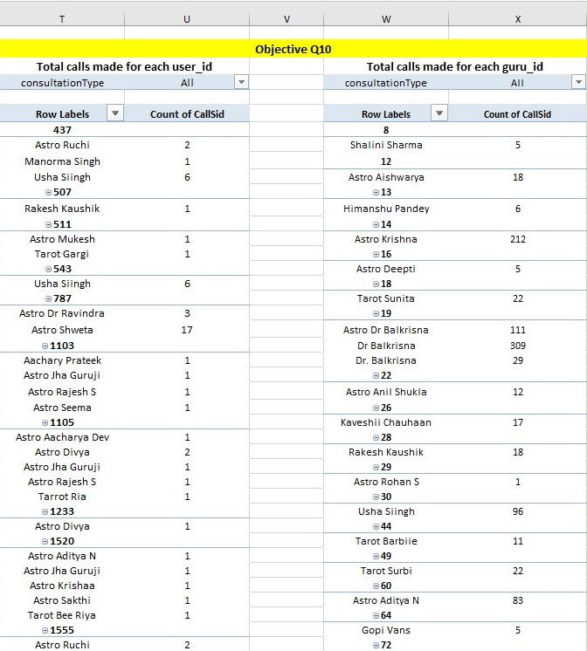

1. What is the correlation between call duration and customer satisfaction?

**Answer –** To calculate correlation between call duration and customer satisfaction , we need **“userOnCallDuration”** COLUMN and **“rating”** COLUMN.

1. Reference: Columns: userOnCallDuration and rating
2. Approach Used: Formula used: **=CORREL(data!AH2:AH28028,data!AI2:AI28028)**

The answer is = **-0.000202451**

1. Key Insights: Correlation: **-0.0002** (weakly negative)
2. **Suggestions:** Long calls don't guarantee satisfaction; focus on quality

Kindly refer the image also attached below.

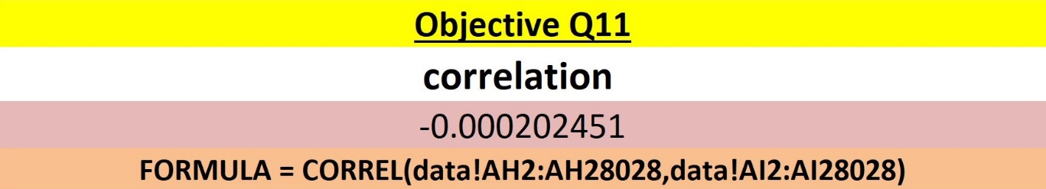

1. Which guru has the highest and lowest customer satisfaction scores?

**Answer –** There are two Guru with the highest customer satisfaction scores namely **Astro Pujaa Rai and Tarot Mystical both with the scores of 7.5**

**AND**

Guru with the lowest customer satisfaction scores is **Tarot Rittika with the score of 0**

Kindly refer the image also attached below.

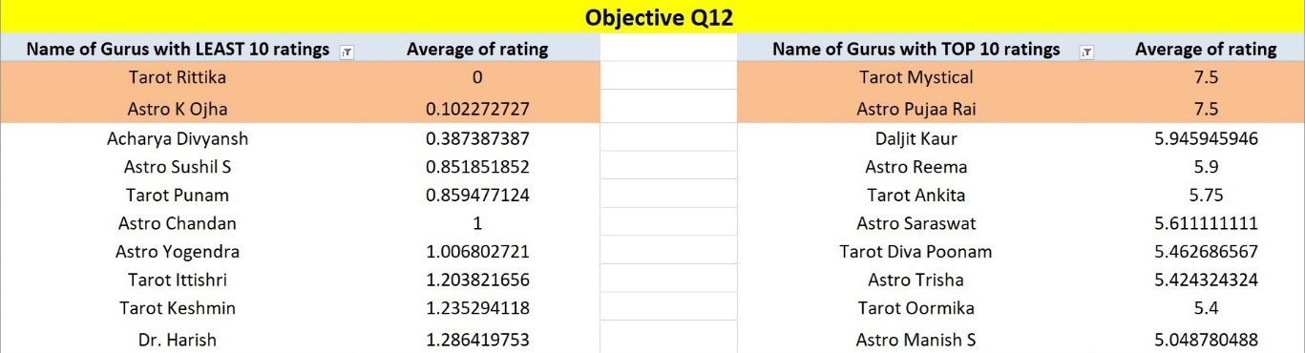

1. What is the average customer satisfaction score by month?

**Answer –** Average customer satisfaction score of December is **2.94945411960258** and of January is **2.67815344603381**

Kindly refer the image also attached below.

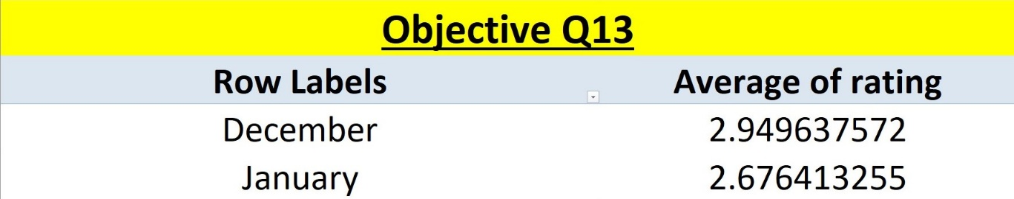

1. How many categorical columns are there in the data? [Search about categorical and continuous data, and try to answer this question]

**Answer –** There are **15 categorical columns** in the ‘Cleaned Data’ Sheet. These include columns with text labels or boolean values that represent categories or characteristics.

Names of the columns are :

1. COLUMN A – **“user”**
2. COLUMN B – **“chatStatus”**
3. COLUMN C – **“guru”**
4. COLUMN D – **“guruName”**
5. COLUMN G – **“consultationType”**
6. COLUMN H – **“website”**
7. COLUMN K – **“freeCall”**
8. COLUMN L – **“freeChat”**
9. COLUMN R – **“callChannel”**
10. COLUMN S – **“callStatus”**
11. COLUMN T – **“CallSid”**
12. COLUMN V – **“astrologerCallStatus”**
13. COLUMN AA – **“region”**
14. COLUMN AB – **“userCallStatus”**
15. COLUMN AI – **“Unique_guruName”**

**Subjective Question:**

1. Should the investment be used to hire more agents, improve training programs, or upgrade call center technology?

**Answer –**

1. **Approach** 
   1. Analyzed call/chat data by filtering **STATUS** to identify sessions marked as **‘INCOMPLETE’** or **‘FAILED’**.
   2. Reviewed the **RATINGS** column to assess overall customer satisfaction.
   3. Observed patterns across the dataset to identify root causes and systemic issues.
2. **Insights**
3. A **high percentage** of sessions are marked as **incomplete or failed**, indicating connectivity or process breakdowns.
4. **Customer satisfaction ratings** are consistently **low** across most interactions.
5. The issue appears **systemic**, pointing beyond just staffing limitations (e.g., technology, training, processes).
6. **Suggestions**
   1. **Upgrade Call Center Technology**: Improve infrastructure to reduce dropped or failed calls, ensure better call clarity, and support AI-assisted routing and monitoring.
   2. **Conduct Agent Training Programs**: Focus on soft skills, handling tools efficiently, and managing calls more effectively to boost satisfaction.
   3. **Implement AI-enabled Quality Monitoring**: Use analytics to track common call failure reasons and flag underperforming interactions for review.
   4. **Prioritize System Reliability**: Ensure stable connections and smooth handoffs between chats and calls.
7. **Recommendations**
   1. **Short-Term**: Initiate focused training sessions for agents and address immediate technical pain points.
   2. **Medium-Term**: Invest in robust call handling systems, including fallback protocols for failed calls.
   3. **Long-Term**: Deploy intelligent automation (e.g., conversational AI, predictive routing) and continuously improve based on analytics.
8. **Hire More Agents**

Average number of calls per day = **246.0294118 (APPROX = 246 CALLS A DAY)**

(Formula Used =AVERAGE())

**Percentage of calls completed = 40.42%**

Formula Used = (completed / grand total) * 100 = (3453 / 8541) * 100

**SUGGESTIONS**

The call centre receives approximately 246 calls per day, but only 40.42% of calls are completed.

Thus , to manage the workload , investment should be used to hire more agents.

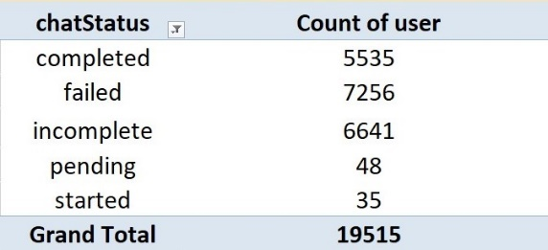 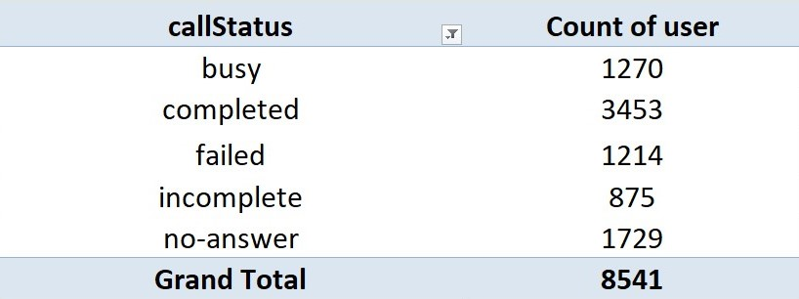

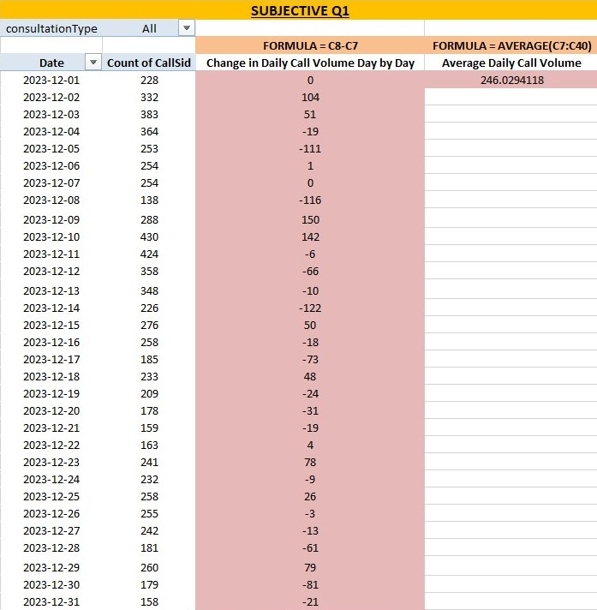

1. **Improve Training Programs**

* Percentage of UnSatisfied user (Ratings – 0 , 1 , 2 , 3 , 4)

= [ ( 7256 + 2199 + 4329 + 4407 + 2132 ) / 28027 ] * 100 = **72.51%**

* Percentage of Satisfied user (Ratings – 5 , 6 , 7 , 8)

= [ ( 2169 + 1829 + 1824 + 1882 ) / 28027 ] * 100 = **27.49%**

Only 27.49% of users are satisfied with the service.

Total users = 28027

**SUGGESTIONS**

I think the investment should be used to improve the training program.

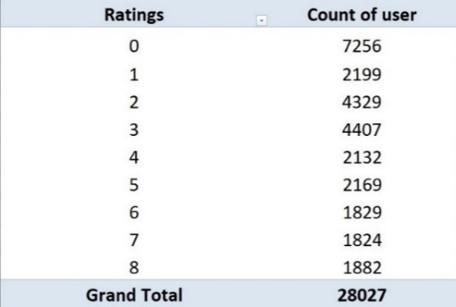

1. **Upgrade Call Center Technology**

72.16% of users use the chat service, primarily through the Gurucool platform from WEBSITE MODE, which has an average rating of just 2.72.

Indicating significant user are dissatisfaction.

**SUGGESTIONS**

This highlights a clear need for technology upgrades to improve service quality, user experience, and retention.

Investing in tech will enhance system performance and satisfaction, though potential risks like implementation delays and training requirements should be planned for and mitigated.

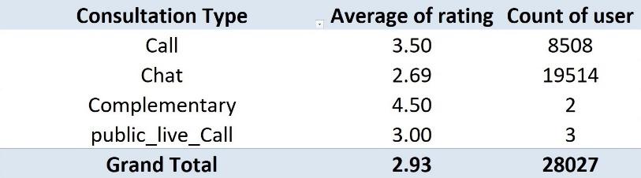

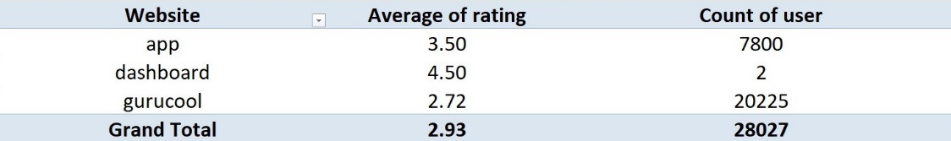

1. What are the potential risks of each investment option (hiring, training, technology upgrades), and how can they be mitigated? Name the chart/spreadsheet function you will use for solving the problem.

**Answer –**

1. **Approach**
2. Hiring Strategy
   * Assess staffing needs based on **forecasted call volumes**.
   * Use **internal referral programs** and **staggered onboarding** to reduce recruitment costs.
   * Plan **on-field training schedules** to avoid resource bottlenecks.
3. Training & Development
   * Implement **cost-effective training** programs.
   * Use **regular assessments** and **refresher sessions** to tackle knowledge retention issues.
   * Monitor **training cost per recruiter** for better budget control.
4. Technology Investment
   * Conduct **ROI analysis** before making high upfront investments.
   * Evaluate scalable solutions to avoid overcapitalizing early.
5. **Spreadsheet Tools & Visualization**
   * Use Excel functions like **AVERAGEIFS()**, **FORECAST()**, **NPV()**, and **COUNTIFS()** for data analysis.
   * Represent data using **Line Charts**, **Bar Charts**, **Pie Charts**, **PivotCharts**, and **Scatter Plots**.
6. **Insights**

* **Hiring Risks**: Overstaffing leads to underutilized resources; high recruitment costs strain budgets.
* **Training Risks**: Significant cost per trainee and risk of low knowledge retention.
* **Technology Risks**: Large upfront investments may not guarantee proportional returns.
* **Mitigation Tactics**:
  + Use **forecasting** to right-size hiring.
  + Rely on **internal networks** to cut recruitment costs.
  + Leverage **continuous learning** to maintain performance.
  + Validate tech investments with **ROI calculations**.

**Key Points:**

* + Hiring risks: Overstaffing, high recruitment cost.
  + Training risks: High cost per trainee, retention issues.
  + Technology risks: High upfront investment.
  + Mitigation: Forecasting, internal referrals, ROI calculations.

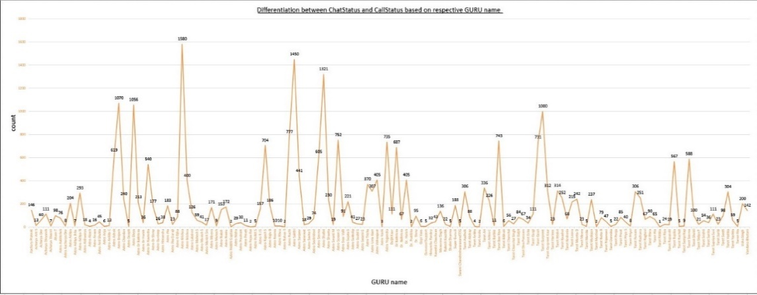

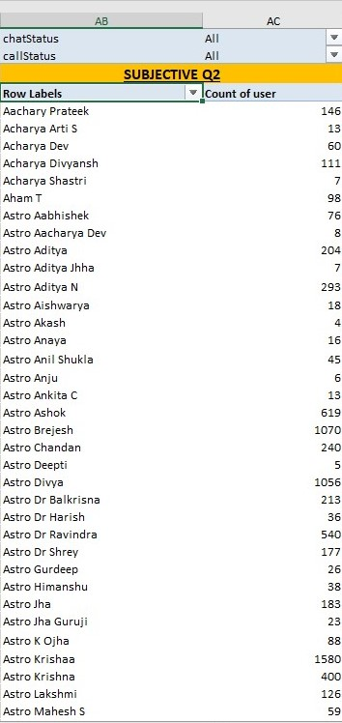

1. How does AstroSage's call center performance compare to AstroGuru's average call volume, customer satisfaction, and agent performance? Will you use any aggregation function or a visualization here to solve the problem?

**Answer –**

1. **Approach**

* Reviewed the provided dataset, which currently contains only AstroSage's internal data.
* Attempted to identify comparative metrics; however, no data for AstroGuru is present, making a direct comparison infeasible.
* Proposed a method assuming AstroGuru’s data were available:
  + Use aggregation functions like AVERAGE(), COUNT(), and MAX().
  + Compare KPIs such as average daily call volume, customer satisfaction ratings, and agent performance.

1. **Insights**

* AstroGuru's performance data is missing, preventing meaningful comparison.
* For a comprehensive competitive analysis, both companies’ datasets are essential.
* Potential KPIs to compare:
  + Average call/chat volume
  + Customer satisfaction/user ratings
  + Agent-level metrics such as average call duration and rating.

1. **Suggestions**

* Request or collect AstroGuru's performance metrics to enable comparative analysis.
* Use Excel functions like:
  + AVERAGE() for mean values of call volume or ratings.
  + COUNT() for total call/chat counts.
  + MAX() for identifying top-performing agents or peak days.
* Once both datasets are available, build clustered bar charts or comparison line charts for clearer visual interpretation.

1. **Recommendations**

* Short-Term: Obtain AstroGuru data (call volume, satisfaction ratings, agent performance).
* Medium-Term: Develop comparative dashboards using aggregation functions and visual tools.
* Long-Term: Regularly update both datasets and track KPIs to inform strategic decisions and identify performance gaps between AstroSage and AstroGuru.

1. The call centre receives around 245 calls a day (APPROX) with a unique count of 131 GURU_IDs available for handling.
2. Only 3452 calls were completed out of 8541 total calls which describes 40.42%
3. Rest 5089 calls were incomplete which shows 59.58%
4. This low completion rate is one of the main reasons why the average rating for the call service is only 3.50

 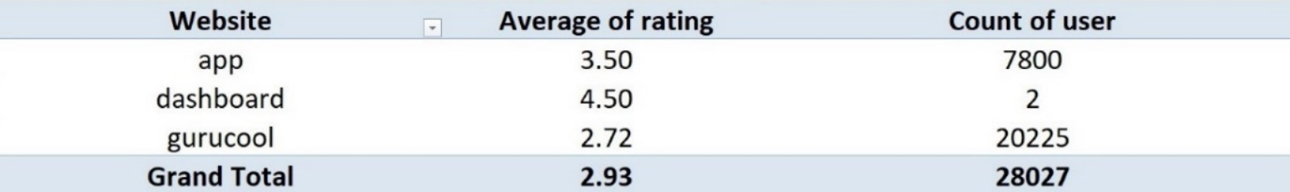

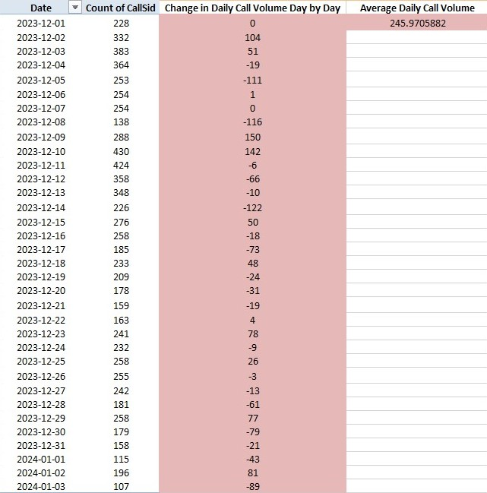

**SUGGESTIONS**

1. If astrologers’ ratings improve, the overall company rating will also improve.
2. Since 78.69% of the company's net income and 78.44% of astrologers’ earnings come from the Call service, it's clearly the key revenue source.
3. So, investing in training programs to improve astrologer performance would be a smart and strategic move to maintain and grow this success.

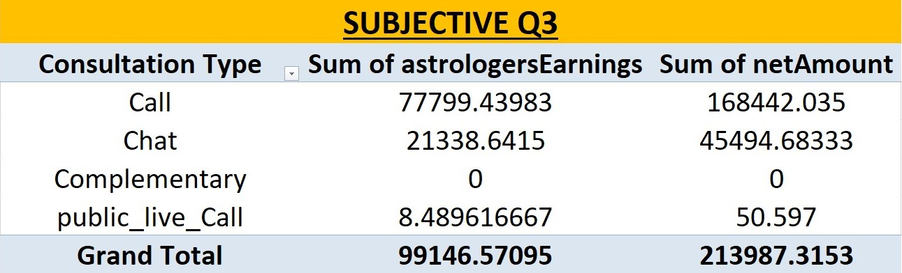

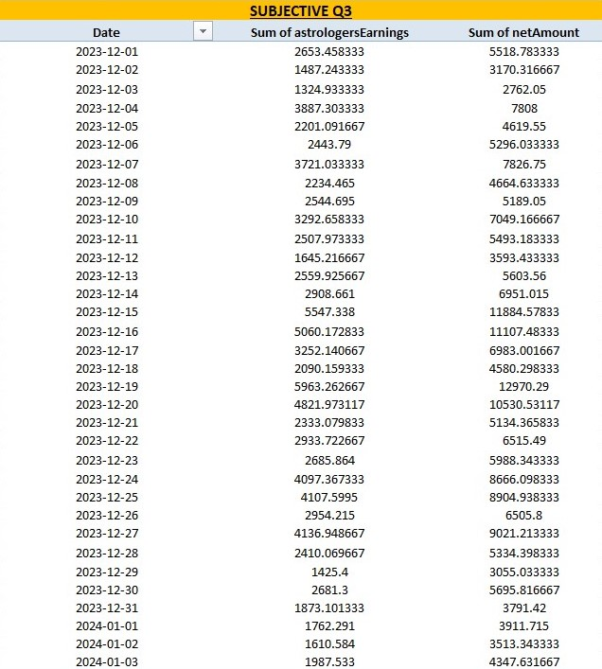

1. How can the call center improve its handling of peak call periods to ensure high customer satisfaction?

Mention the functionality you will use for giving the suggestions, will it be any aggregated function or a visualization?

**Answer –**

1. **Approach**
   1. Forecast and Identify Peak Periods
      * Use the FILTER option to isolate call records by Created_Date, then sort on a daily basis.
      * Apply Excel functions:
        + COUNTIFS() – to calculate number of calls per day.
        + AVERAGEIFS() – to find average daily rating.
        + Pivot Table – with Created_Date in rows and User_Id in values to summarize daily consultation volume.

* Smart Staffing
  + Match staffing levels to peak demand periods identified from the above analysis.
  + Utilize part-time, flexible, or in-training staff to handle overflow during busy periods.
* Introduce Call-Back Option
  + For users who give low ratings, implement a Call-Back feature to offer them a follow-up session with a different agent.
* Train Agents for Peak Hour Scenarios
  + Conduct simulations and stress-management workshops focused on handling high-pressure situations and improving soft skills.

1. **Insights**
2. Peak call periods can be clearly identified through call volume trends on a daily basis.
3. Low ratings often correlate with agent unavailability or delays, especially during high-demand hours.
4. User dissatisfaction may stem from wait times or poor handling during rush hours.
5. Agent soft skill gaps emerge under pressure, requiring specific training.
6. **Suggestions**
   1. Forecast call trends using daily analytics to optimize scheduling.
   2. Balance workforce supply and demand by aligning staff numbers to call volume.
   3. Use part-time or trainee agents to provide support during peak hours.
   4. Add a Call-Back service for recovery from poor user experiences.
   5. Initiate specialized training focused on peak-hour stress and customer empathy.
7. **Recommendations**

* Short-Term:
  + Analyze call volume using COUNTIFS() and pivot tables.
  + Schedule part-time or backup staff during predicted peak times.
* Medium-Term:
  + Develop and deploy a Call-Back mechanism for dissatisfied users.
  + Begin agent workshops and simulations for peak-time readiness.
* Long-Term:
  + Implement automated forecasting tools and dynamic scheduling.
  + Track improvements in user satisfaction linked to these interventions.

1. Analysis of PEAK DAY
   1. Day with the Highest calls = **10th December 2023 and 11th December 2023**
   2. Day with the Lowest calls = **3rd January 2024 and 1st January 2024**
   3. Only **40.42% of users were successfully served by Astrologer**, while the remaining **59.58%** received messages such as **"astrologer busy" @14.87%** or had their **calls cancelled** due to the unavailability of Astrologers with the remaining of 44.71% (59.58% - 14.87%)
2. Analysis of PEAK Hour
   1. Hour with Most Calls = **Morning 8am and 10am**
   2. Hour with Least Calls = **Mid–NIGHT 12am and 1am**

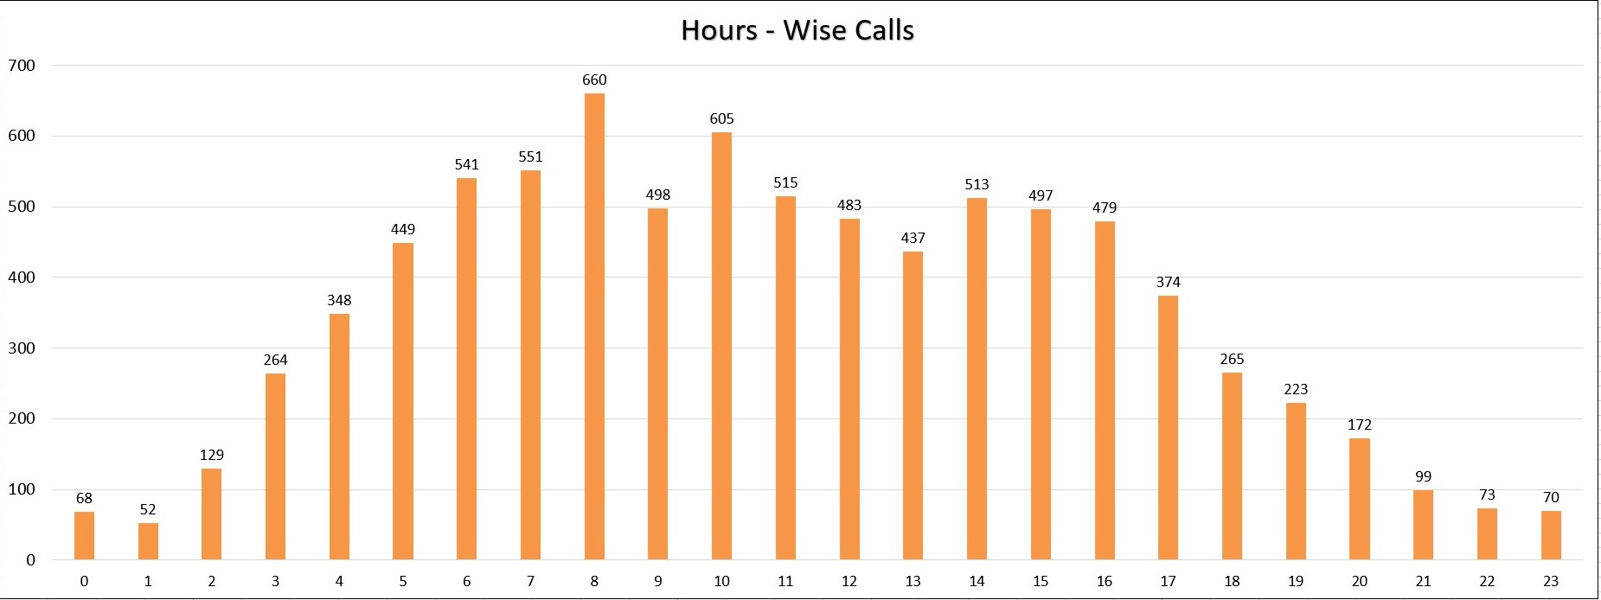

Here we can see the hourly distribution of calls.

* First, **“created_Hour”** column is extracted from **“created_Time”** with the HOUR() Function and being formula used **=HOUR(P4).**
* Later , created a PIVOT TABLE taking hours in a row, the count of callSid in values.
* At last , it is being visualised as a PIVOT CHART.

1. **Introduce Live Streaming:**

The company can offer live sessions where astrologers interact with multiple users at once. This will reduce waiting time, keep users engaged, and also help generate more revenue.

1. **Optimize Agent Shifts:**

Schedule more agents during peak hours (like evenings or weekends) to handle higher call volumes efficiently.

1. **Hire Part-time or Freelance Agents:**Keep a few on-call or freelance astrologers who can step in during busy times.

This helps manage the load without adding permanent staffing costs.

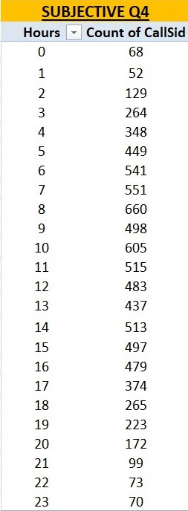 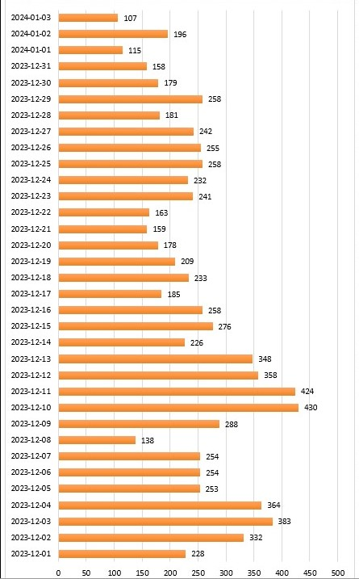

1. Based on historical data, what strategic initiatives should be prioritized to improve efficiency and customer satisfaction?

**Answer –**

1. **Approach**
   1. Analyze **session failure reasons** such as technical issues, user drop-offs, or astrologer unavailability to identify process bottlenecks.
   2. Propose **real-time system improvements** like alert triggers or automatic fallback to chat in case of failed call connections.
   3. Evaluate **astrologer performance** using key metrics like:
      1. **Earnings per minute/second**
      2. **Average customer ratings**
   4. Implement regular **performance-based incentives** for astrologers.
   5. Go beyond ratings to evaluate **true customer satisfaction**, including:
      1. Repeat usage behavior
      2. User retention patterns
2. **Insights**
3. **High session failure rates** suggest gaps in technical infrastructure or operational flow.
4. **Lack of performance monitoring** may allow inefficiencies to go unaddressed.
5. **One-dimensional satisfaction metrics** (e.g., ratings alone) miss the full picture of user engagement**.**
6. **Repeat users and loyalty patterns** are strong indicators of satisfaction and should be studied more deeply.
7. **Suggestions**
8. **Introduce real-time alerts or automated fallback options** (e.g., switch to chat if calls fail).
9. Perform **routine performance assessments** of astrologers, focusing on both speed and quality.
10. **Launch incentive programs** to boost performance and morale among astrologers.
11. Track and **analyze behavior of repeat users** to understand what drives satisfaction.
12. Introduce **loyalty perks or rewards** for frequent users to improve retention and engagement.
13. **Recommendations**
14. **Short – Term:**
    * Conduct a root-cause analysis of session failures.
    * Set up fallback-to-chat mechanisms for failed call attempts.
15. **Medium – Term:**
    * Implement dashboards for astrologer performance tracking.
    * Start monthly incentive programs based on performance data.
16. **Long – Term:**
    * Develop a customer loyalty program to recognize and retain repeat users.
    * Continuously refine satisfaction metrics using user behavior analytics.

Strategy A)

Training Programs

* Percentage of UnSatisfied user (Ratings – 0 , 1 , 2 , 3 , 4)

= [ ( 7256 + 2199 + 4329 + 4407 + 2132 ) / 28027 ] * 100 = **72.51%**

* Percentage of Satisfied user (Ratings – 5 , 6 , 7 , 8)

= [ ( 2169 + 1829 + 1824 + 1882 ) / 28027 ] * 100 = **27.49%**

Only 27.49% of users are satisfied with the service.

Total users = 28027

**SUGGESTIONS**

I think the investment should be used to improve the training program.

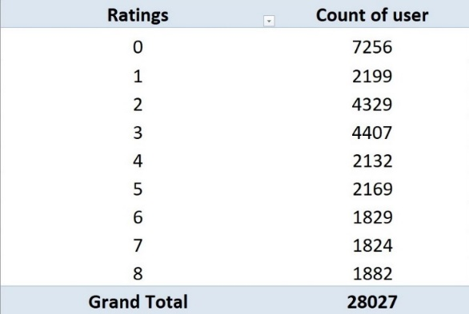

STRATEGY B)

Upgrade Technology.

72.16% of users using the **chat service** and a primarily through the Gurucool platform from WEBSITE MODE, which has an average rating of just 2.72.

**SUGGESTIONS**

There is a clear **need to enhance the chat platform** for a smoother user experience.



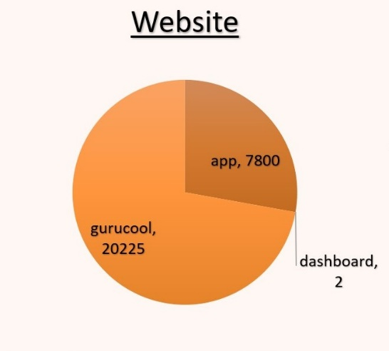

STRATEGY C)

Optimize Staffing During Peak Hours



1. Day with the Highest calls = **10th December 2023 and 11th December 2023**
2. Day with the Lowest calls = **3rd January 2024 and 1st January 2024**
3. Only **40.42% of users** of users got service.
4. While **59.58% of users** received messages such as **"astrologer busy" @14.87%** or had their **calls cancelled** due to the unavailability of Astrologers with the remaining of 44.71% (59.58% - 14.87%)
5. Use shift planning, part-time astrologers, or live sessions to better handle high traffic.

**SUGESSTIONS**

This move can make the company stand separate among the rivals. And bring customers and revenue to the company.

1. What can be the key factors contributing to high customer satisfaction scores, and how can these be leveraged to improve overall performance? What is the basis for the suggestions? And mention how you decided if the satisfaction score affects the ratings.

**Answer –**

1. **Approach**

* Used **Ratings** as **the primary and quantitative proxy for customer satisfaction**, since no separate satisfaction score exists in the dataset.
* Performed correlation analysis between:
  + - **Astrologers' Earnings**
    - **netAmount**
    - **Ratings**
* Evaluated the impact of session attributes (like **call duration, repeated chats, and session completion status**) on user satisfaction.

1. **Insights**

* **Ratings** are the only explicit measure of customer satisfaction in the dataset.
* **No separate satisfaction score** column confirms that ratings must be treated as the satisfaction score.
* **Stronger correlation** found between **astroloagersEarnings / netAmount** and **high ratings** — indicating that high-performing astrologers tend to deliver more satisfactory sessions.
* **Call duration** shows a **weak correlation** with satisfaction — longer calls do not necessarily result in higher ratings.
* **Repeated low-rated chats** may signal the need for escalation or improved service for certain users.

1. **Suggestions**

* **Enhance platform reliability** to minimize dropped or incomplete sessions — a common source of dissatisfaction.
* **Empower astrologers** to deliver **concise, high-quality, and structured consultations**, focusing on clarity and relevance rather than duration.
* **Implement escalation protocols** for users who frequently give low ratings, to ensure their concerns are addressed effectively.
* **Track repeated chats** and introduce **specialized support or follow-up mechanisms** for users with unresolved issues.

1. **Recommendations**

* **Short – Term:**
  + **Treat Ratings as the definitive customer satisfaction score.**
  + Begin tracking astrologer performance with respect to **earnings-to-ratings ratio.**
* **Medium – Term:**
  + Optimize **training programs** to focus on delivering **value in less time**, without compromising session quality.
  + Develop a system to **escalate cases** of repeated dissatisfaction.
* **Long – Term:**
  + Use ongoing **correlation analysis** to continuously improve platform features, astrologer support, and session design.
  + Reward astrologers based on **quality of interactions** (ratings and earnings), not call duration.

**69.63%** of total users use the chat service.

Rating of 5 , 6 , 7 , 8 is considered as the high satisfaction range.

Only chat service receives the rating of 6 , 7 , 8.

As **69.63%** **%** of total users use the chat service , and

100% of high satisfaction scores is given by chat user only, then the Chat service can be considered as the key factor contributing to high satisfaction score.

**Improvements:**

* To further enhance user experience, the company can:
  + Introduce AI chatbots to handle basic queries and reduce wait times.
  + Train employees to adopt new tools, technologies, and workflows that support better service delivery.
* These steps will help the company boost overall performance and user satisfaction.

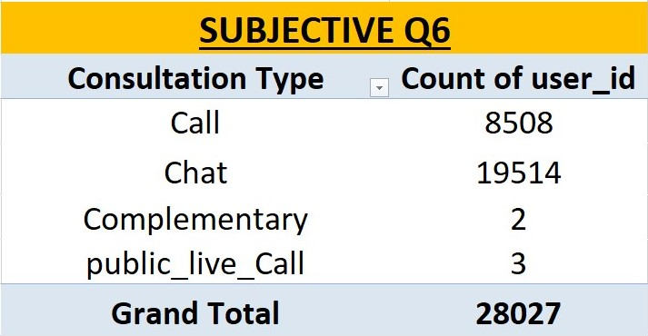

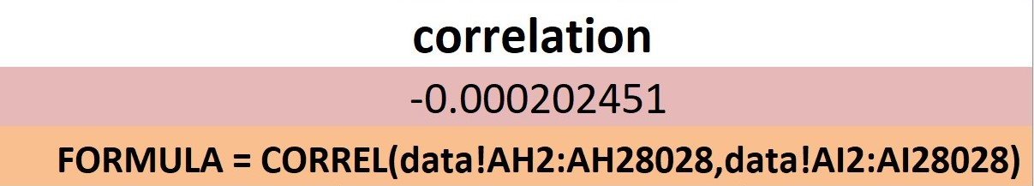

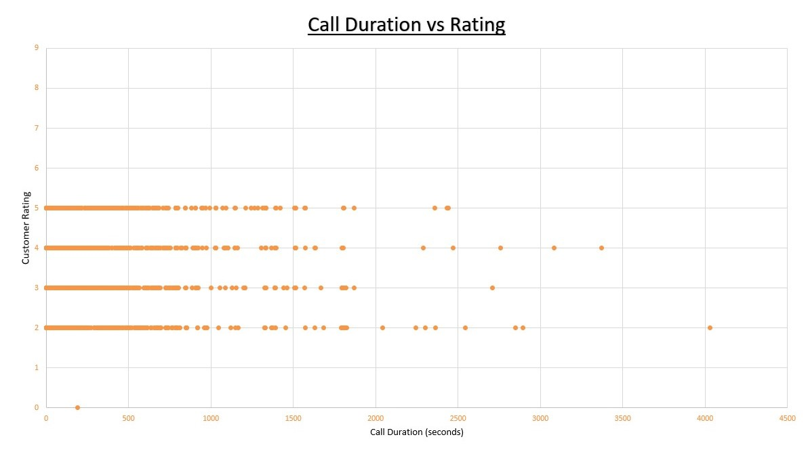

1. How should the call center balance the workload among agents to ensure optimal performance and avoid burnout?

Mention your approach and spreadsheet function for the answer.

**Answer –**

**A) Approach**

* **Daily Workload Tracking**:
  1. Use spreadsheet functions to track each agent’s task volume throughout the day.
* **Formula Application**:
  1. SUM() – Calculate total workload per agent.
  2. AVERAGE() – Determine the average workload across all agents.
* **Equitable Load Distribution**:
  1. Compare individual workloads against the average to identify overburdened or underutilized agents.
* **Staffing Adjustments**:
  1. Use this data to guide shift planning, rest breaks, and task redistribution.

**B) Insights**

* **Uneven Distribution**:
  + Without proper tracking, some agents may be overloaded, leading to burnout, while others are underused, reducing productivity.
* **Impact on Morale & Quality**:
  + Balanced workloads lead to improved job satisfaction, better performance, and reduced turnover.
* **Operational Visibility**:
  + Real-time workload data helps supervisors make informed decisions and maintain consistency across teams.

**C) Suggestions**

* Create a **daily workload dashboard** using Excel with visual cues (e.g., conditional formatting) to highlight outliers.
* Introduce a **rest/support flag** for agents consistently above the average workload.
* Use **PivotTables** for quick summaries by agent, shift, or day.
* Automate the data entry process with **forms or scripts** to ensure consistency.

**D) Recommendations**

* Implement a **workload monitoring system** using SUM() and AVERAGE() functions.
* Regularly review agent performance and balance workloads based on actual data, not assumptions.
* Include **workload balancing in supervisor KPIs** to maintain fairness and avoid burnout.
* Use insights to optimize **staffing levels and break schedules**, especially during peak hours.

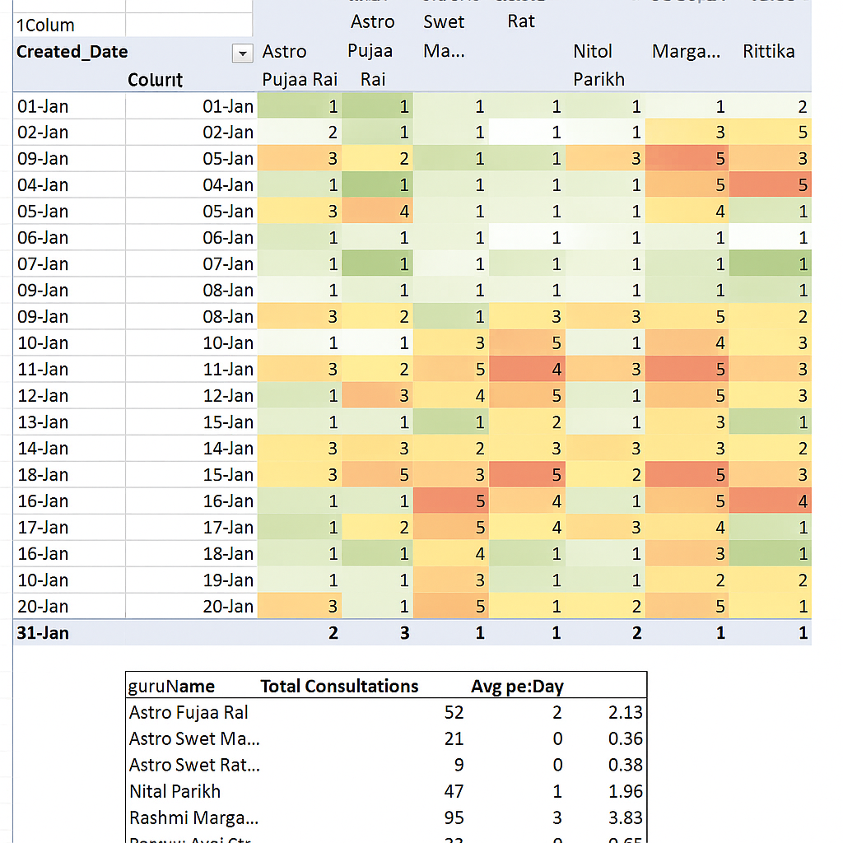

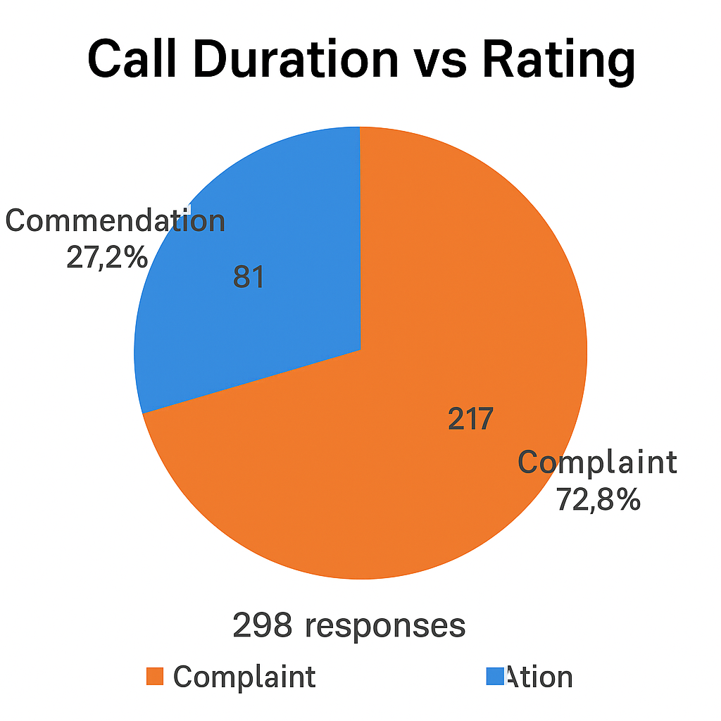 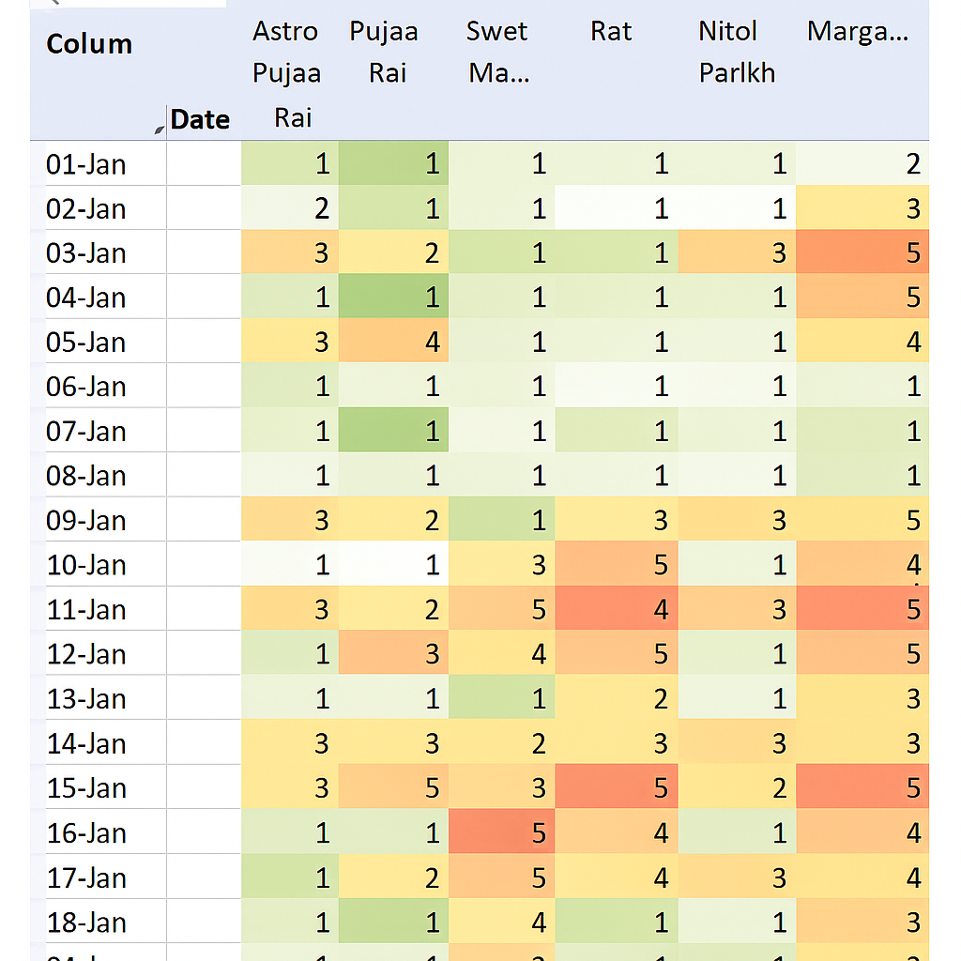

1. What new technologies or tools could be implemented to enhance call center operations and customer service?

**Answer –**

**a. Approach**

* AI-Driven Call Center Modernization:  
  Leverage the latest artificial intelligence technologies to automate, personalize, and optimize customer interactions and internal operations.
* Tech Stack Implementation Areas:
  + Intelligent Call Routing (ICR) – Match users with the most suitable astrologer based on preferences and history.
  + Conversational AI – Automate first-level queries and reduce human workload.
  + Real-Time Dashboards – Monitor live agent and system metrics for better responsiveness.
  + Workforce Management Tools – Forecast and balance staffing using AI.
  + Voice Analytics & Sentiment Detection – Capture emotional cues in conversations.
  + Knowledge Management Platforms – Help agents deliver faster and more accurate responses.
  + CRM Integration – Deliver personalized service using past data and preferences.

**b. Insights**

* Call Mismatches Impact Quality:  
  Manual routing often leads to misalignment between customer needs and astrologer expertise — ICR directly solves this.
* Routine Queries = Time Drain:  
  FAQs and refund questions dominate first-level support. Chatbots can handle these instantly, saving agent time.
* Performance Gaps Go Unnoticed:  
  Without real-time analytics, high wait times or dropped calls go unaddressed — dashboards enable quick intervention.
* Agent Burnout is Preventable:  
  Uneven workloads cause top performers to burn out — WFM tools prevent this with balanced, predictive scheduling.
* User Sentiment is Underused:  
  NLP-based voice analytics can detect dissatisfaction in real time — allowing proactive recovery before escalation.
* Inconsistent Responses Affect Trust:  
  Agents without access to guided content or remedies may offer inaccurate information — knowledge platforms fix this.
* Customer Retention Hinges on Personalization:  
  Users expect services to remember them — CRM integration helps repeat users feel valued and boosts loyalty.

**c. Suggestions**

* Pilot ICR and chatbot systems in one department first to track improvements before scaling.
* Train staff on interpreting sentiment analytics to turn emotional signals into action (e.g., escalating calls, offering discounts).
* Use dashboards as live command centers for supervisors to respond instantly to traffic spikes or performance drops.
* Create a centralized knowledge base with AI tagging for faster access during live consultations.
* Segment users based on CRM data and offer personalized dashboards and predictions for frequent users.

**d. Recommendations**

* Implement Intelligent Call Routing (ICR):  
  Match customers with astrologers based on profile, language, and expertise — increasing satisfaction and resolution rates.
* Deploy Conversational AI & Chatbots:  
  Handle FAQs, bookings, and refund queries autonomously — reducing agent load and improving response speed.
* Install Real-Time Analytics Dashboards:  
  Track key performance indicators like agent availability, wait times, dropped calls, and sentiment — enabling responsive action.
* Adopt Workforce Management (WFM) Tools:  
  Predict call volumes and assign agents smartly — ensuring fair shifts and preventing burnout.
* Utilize Voice Analytics with Sentiment Detection:  
  Monitor emotional tones in live conversations — trigger alerts for negative experiences and escalate when needed.
* Integrate CRM with Excel-Based Caller History:  
  Show astrologers past interactions and preferences in real time — boosting personalization and user retention.
* Use Knowledge Management Systems:  
  Help astrologers deliver accurate remedies/scripts efficiently — improving trust and standardization.

**e. Key Points Summary**

* Use **ICR** for precise call routing.
* Implement **AI chatbots** for 24/7 FAQ handling and load reduction.
* Deploy **real-time dashboards** and **sentiment detection** for live performance tracking.
* Adopt **CRM integration** and **knowledge platforms** for personalized and consistent service delivery.

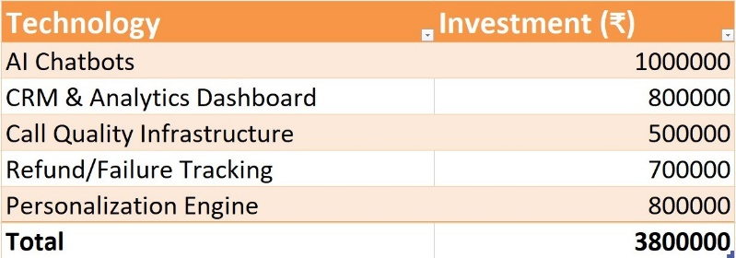

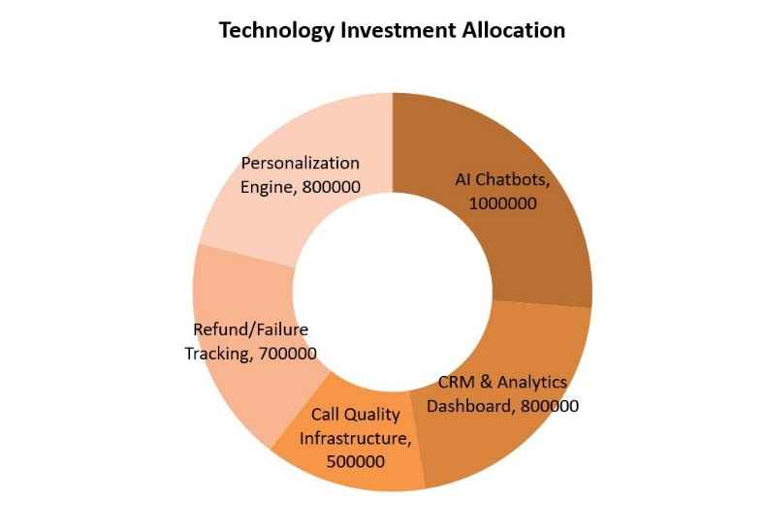 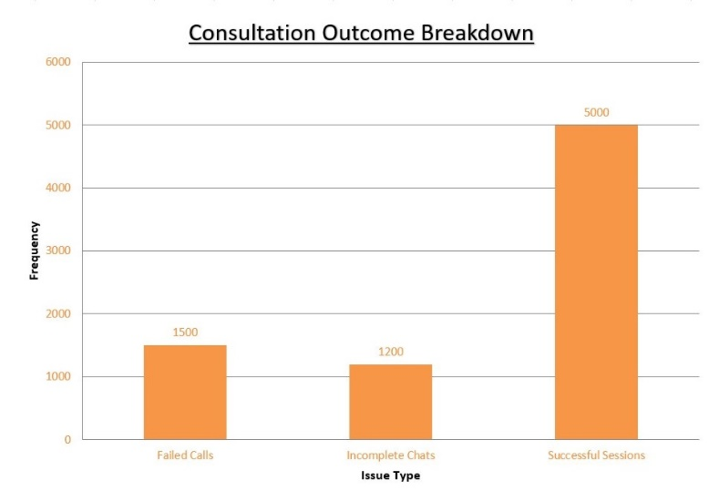

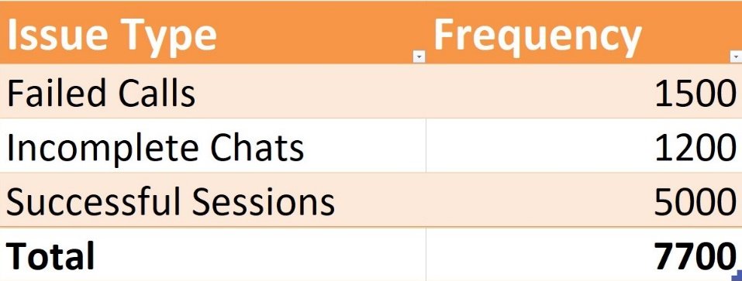

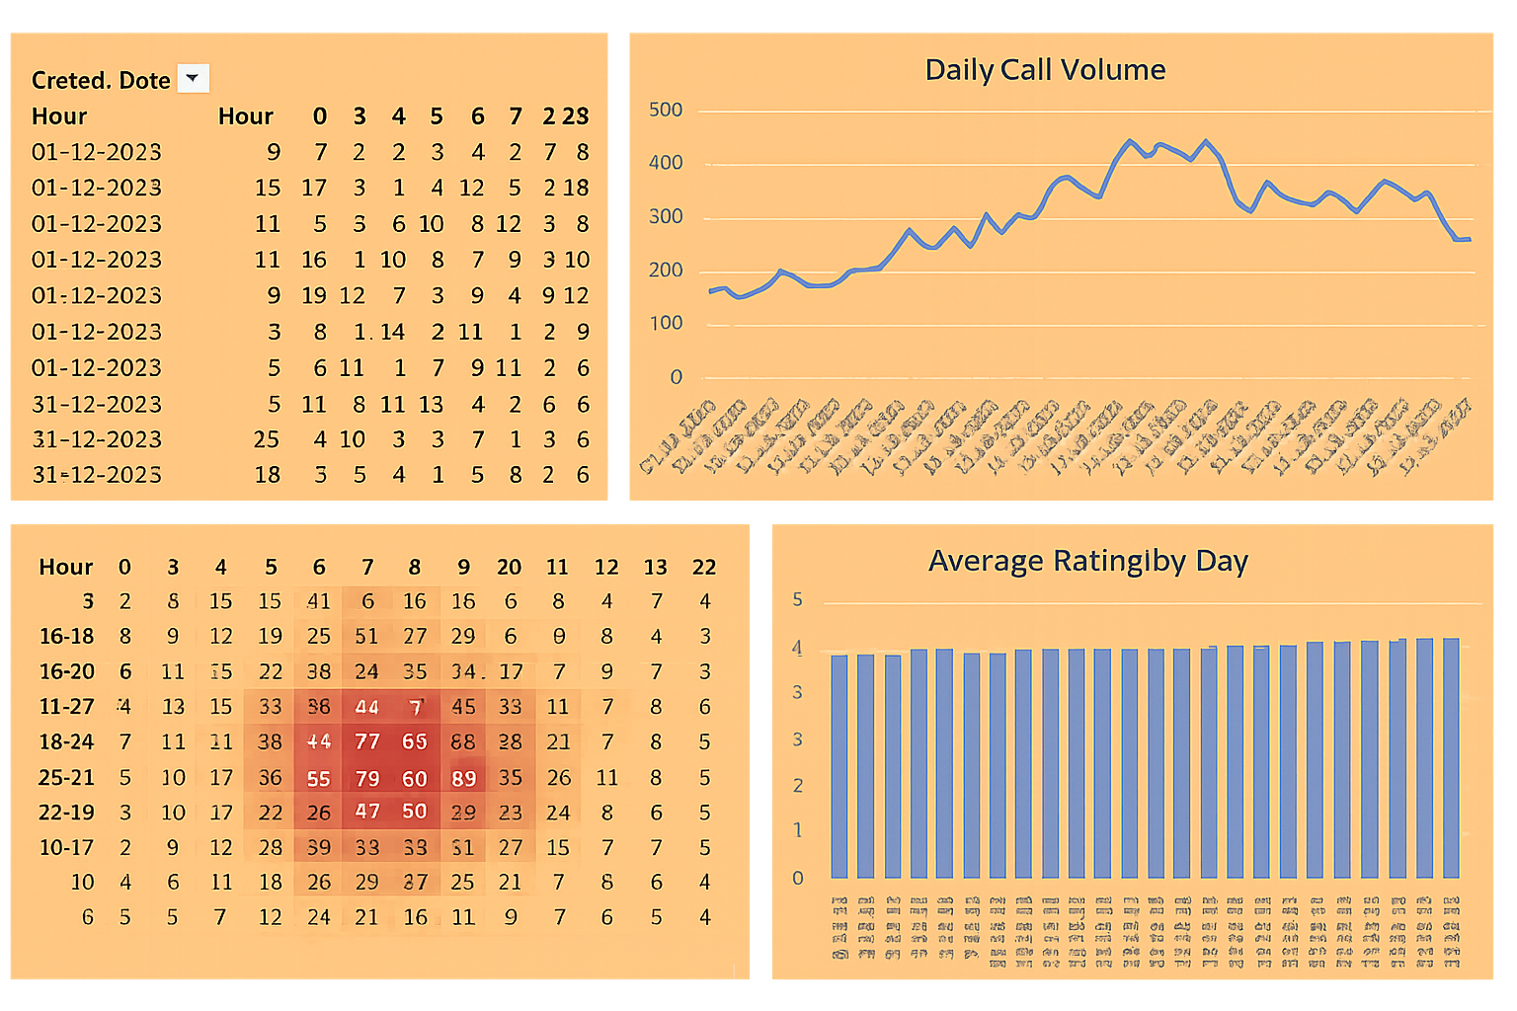



1. What metrics should be included in the final dashboard to comprehensively view call center performance and guide investment decisions?

**Answer –**

**a. Approach**

* Build a Multi-Dimensional Dashboard:  
  Incorporate **operational**, **financial**, **customer experience**, and **forecasting** metrics to provide a complete view of performance.
* Categorize Metrics:
  + **Operational**:
    - Total Calls Handled
    - Average Talk Time
    - Call Volume by Time (hour/day/week)
  + **Customer Experience**:
    - Customer Satisfaction Score (CSAT)
  + **Financial**:
    - Cost per Call
    - Revenue per Call
    - Return on Investment (ROI)
  + **Trend & Forecasting**:
    - Monthly Call Volume Trend
  + **Actionable KPIs**:
    - Technology Utilization (e.g., % of queries handled by chatbots)
* Visualization Techniques:
  + Use **line charts** for trends, **bar/pie charts** for comparisons, and **pivot tables with slicers/filters** for dynamic exploration.

**b. Insights**

* Operational Volume:  
  Tracking total calls and peak times helps align staffing with demand.
* Talk Time Patterns:  
  Average talk time reveals agent productivity and call complexity.
* Satisfaction Score Trends:  
  CSAT helps gauge the quality of customer interactions and agent effectiveness.
* Cost Efficiency:  
  Cost per call indicates operational efficiency, while revenue per call shows profitability.
* Forecasted Traffic Trends:  
  Monthly call volume projections guide hiring and tech scaling decisions.
* Technology Utilization:  
  A low utilization rate may indicate underused tools, while high use suggests successful automation.

**c. Suggestions**

* Use **interactive filters/slicers** (e.g., by date, region, agent) to drill down into performance.
* Add **conditional formatting** to highlight KPIs falling below targets (e.g., low CSAT or high cost per call).
* Integrate **trendlines and moving averages** for clearer forecasting insights.
* Include a **real-time performance tracker** for operational metrics like call queue or wait time.
* Automate data collection using **connected Excel sheets, CRM data exports, or APIs**.

**d. Recommendations**

* **Develop a comprehensive dashboard** that blends operational, financial, and experience metrics for 360° performance insight.
* **Regularly review technology utilization KPIs** to determine ROI on AI, CRM, and chatbot investments.
* **Use call volume trends and forecast data** to optimize staffing, training, and tech scaling strategies.
* **Incorporate time-based visuals and dynamic filters** for executive and team-level reporting flexibility.
* **Align investment decisions** with metrics like ROI, revenue per call, and satisfaction score improvement areas.

**Key Points Summary**

* 📊 Metrics to Track: Total calls, talk time, CSAT, cost/revenue per call, ROI
* 📈 Visual Tools: Trend lines, charts, slicers, and filters for dynamic analysis
* 🎯 Actionable KPIs: Technology usage, peak call times, monthly forecast trends
* 💡 Goal: Enable real-time performance monitoring and informed investment decisions

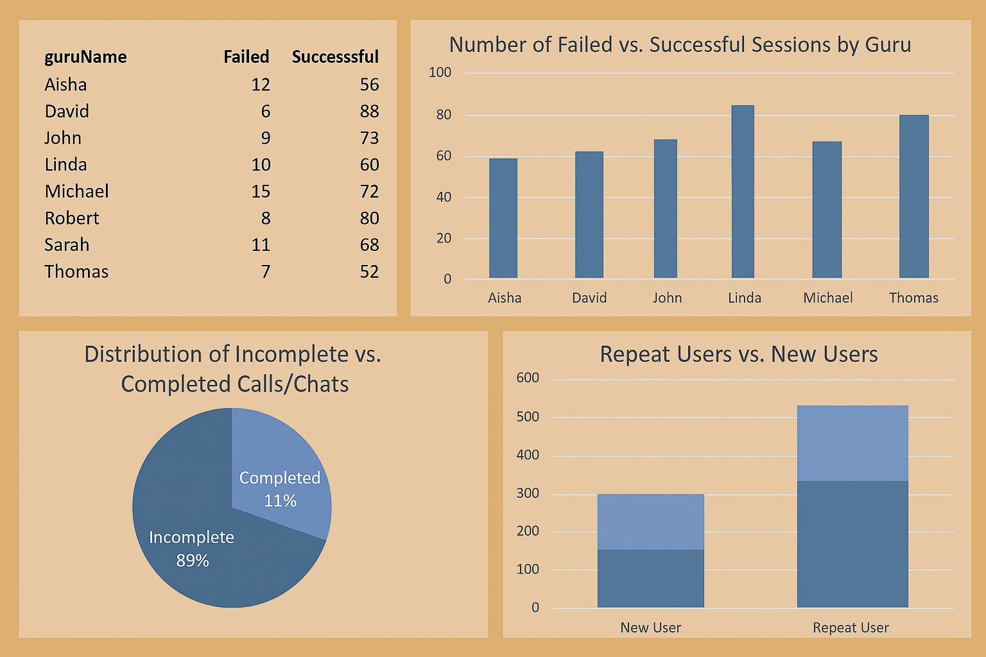

 

1. How would you allocate a 1 crore rupee investment to optimize operational efficiency, enhance customer satisfaction, and boost profitability, and what analysis-based recommendations would you offer to support this?

[you have to give bullet pointers to answer this question]

**Answer –**

The ₹1 crore investment should be strategically distributed. ₹30 lakhs should be used for operational efficiency (AI chatbot, CRM, call infra), ₹35 lakhs for improving customer satisfaction (training, support, loyalty), and ₹35 lakhs for profitability growth (ads, partnerships, pricing tools). This allocation aligns with the observed issues like incomplete calls, low ratings, and repeat users.

**a. Approach**

* Strategic Allocation of ₹1 Crore into three key areas:
  + ₹30 Lakhs – *Operational Efficiency*
  + ₹35 Lakhs – *Customer Satisfaction*
  + ₹35 Lakhs – *Profitability Growth*
* Data-Driven Investment Decisions:  
  Each segment is mapped directly to specific platform issues identified in the data, such as incomplete chats, failed sessions, and low user ratings.

**b. Insights**

* Platform Reliability Issues:  
  High number of “incomplete” or “failed” chats suggests weak backend infrastructure or scheduling conflicts.
* Service Quality Gaps:  
  Low customer ratings highlight inconsistency among astrologers, emphasizing the need for better training and performance monitoring.
* Retention Opportunities:  
  Repeat users and chats indicate a strong base for loyalty and referral programs, which are currently underutilized.
* Revenue Leakage:  
  Zero-earning sessions point to failed monetization — either due to technical issues or missing pricing structures.
* Poor User Profiling:  
  “Region = Unknown” limits personalization and market targeting; profiling must improve for localized recommendations and offers.

**c. Suggestions**

* Use AI-driven chatbot & scheduling tools to reduce drop-offs and incomplete sessions.
* Develop personalized recommendations using CRM data to increase conversion and satisfaction.
* Empower astrologers with regular training and feedback loops tied to user reviews and session success.
* Launch ROI-measured ad campaigns and collaborations with influencers for growth and visibility.
* Introduce dynamic pricing models based on demand patterns to better monetize services.
* Enrich user data collection to eliminate “unknown” fields, especially for regional segmentation.

**d. Recommendations**

I. ₹30 Lakhs – Operational Efficiency

* ✅ ₹10L – AI Chatbot & Scheduling Automation: Resolve incomplete session issues.
* ✅ ₹8L – CRM & Dashboard Systems: Monitor customer journeys and agent activity.
* ✅ ₹7L – Refund/Failure Status Tracking: Reduce financial leakages from failed sessions.
* ✅ ₹5L – Call Infrastructure Upgrades: Improve connection stability and reduce failed calls.

II. ₹35 Lakhs – Customer Satisfaction

* ✅ ₹10L – Astrologer Training & Incentivization: Address quality gaps.
* ✅ ₹8L – Personalization Engine: Recommend astrologers/services based on past behavior.
* ✅ ₹7L – 24/7 Support Team: Offer real-time problem resolution.
* ✅ ₹5L – Loyalty & Referral Programs: Target existing repeat users for retention.
* ✅ ₹5L – Mobile App Enhancements: Fix bugs, improve UX to reduce churn

.

III. ₹35 Lakhs – Profitability Growth

* ✅ ₹12L – ROI-Focused Ad Campaigns (Google, Meta, etc.): Acquire new users efficiently.
* ✅ ₹10L – Affiliate & Influencer Collaborations: Expand reach via creator networks.
* ✅ ₹8L – White-Label & Premium Listings: Allow top astrologers to boost visibility for a fee.
* ✅ ₹5L – Pricing Optimization Tools: Maximize revenue per session with demand-based pricing.

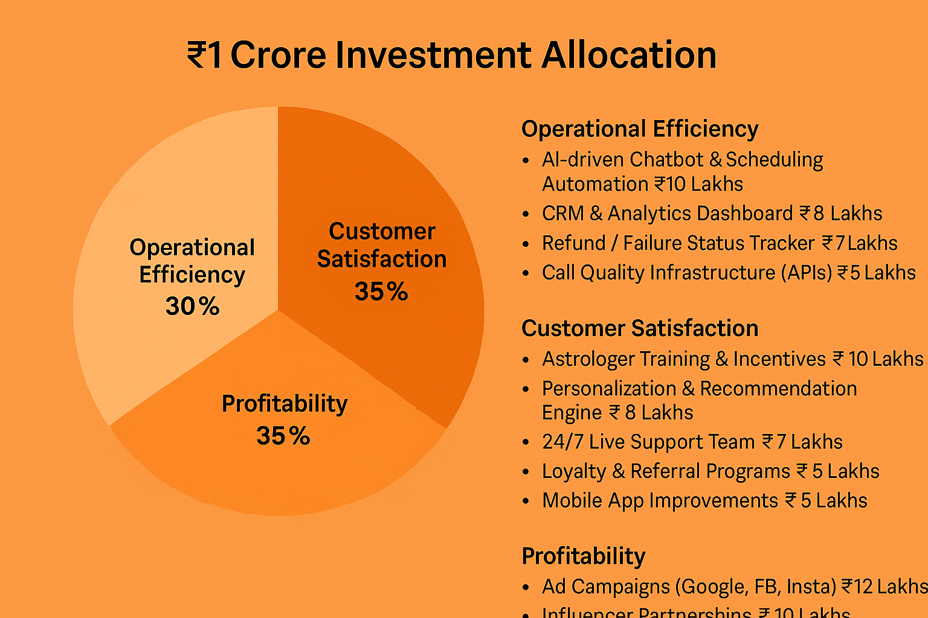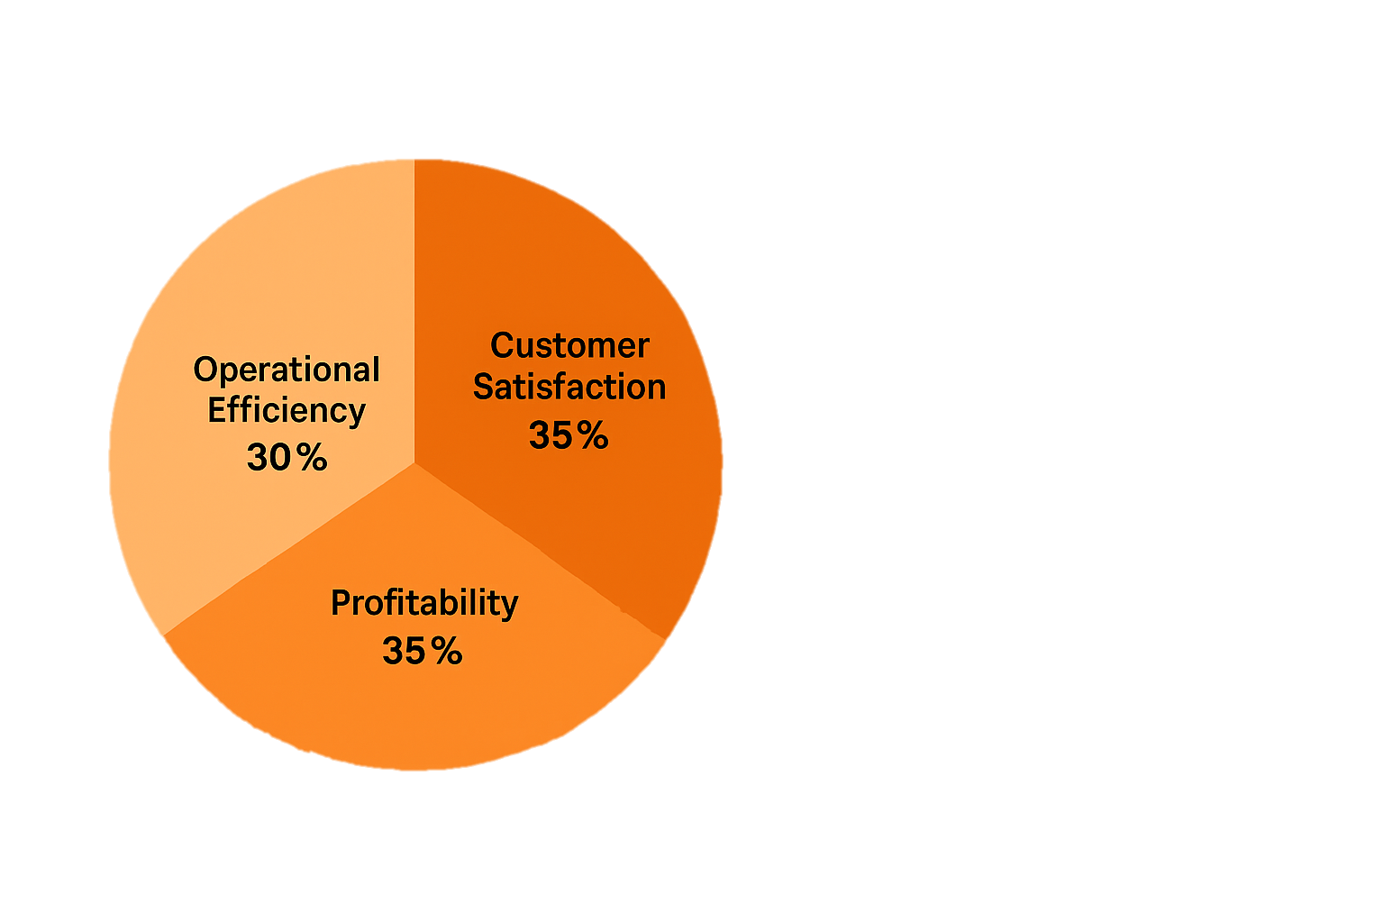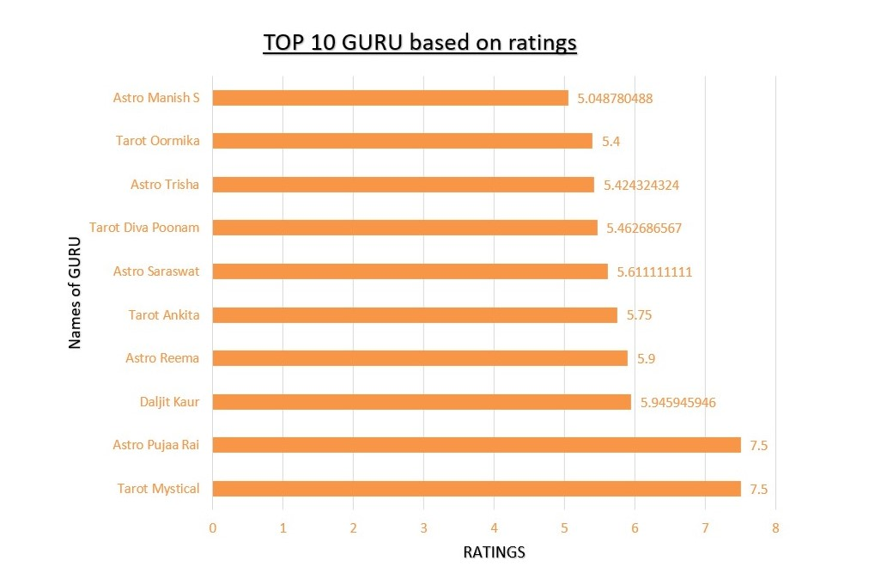



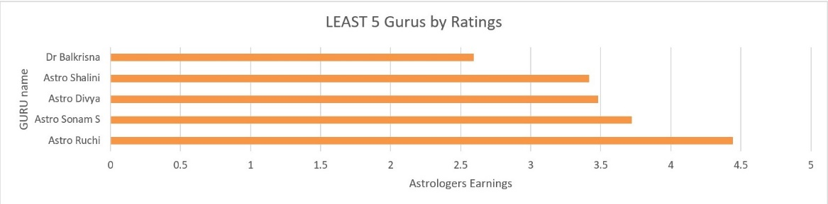

**Conclusion**

This project provided a comprehensive analysis of AstroSage's call center operations using Excel-based tools and data science techniques.

A **₹1 crore investment plan** was proposed, thoughtfully distributed among operational, customer experience, and profitability enhancements.

**A) Overview**

This project delivered a comprehensive analysis of **AstroSage’s call center operations**, leveraging **Excel-based tools** and **data science techniques** to drive strategic insights and actionable outcomes.

**B) Data Transformation Process**

* The **data cleaning phase** involved converting raw, unstructured records into a structured, analysis-ready format.
* This enabled deep dives into **operational patterns**, **user behavior**, and **financial efficiency**.

**C) Key Insights**

1. 📞 Call Volume Trends:  
   December experienced the highest traffic, while January saw the lowest — indicating seasonal demand fluctuations.
2. ⏱️ Call Duration vs. Satisfaction:  
   A weak negative correlation was found, revealing that longer calls don’t necessarily mean better customer experience.
3. ⚠️ Incomplete/Failed Interactions:  
   A significant percentage of calls and chats were either incomplete or failed, pointing to a need for technology upgrades and agent upskilling.
4. 🔁 Repeat User Engagement:  
   Over 68% of sessions were from returning users, emphasizing potential for loyalty programs and personalized recommendations.
5. 💰 Cost Benchmark Variability:  
   Operational costs differed based on whether astrologer earnings or net revenue was used, showing the importance of clear financial KPIs.

D) **Strategic Recommendations**

* ✅ Technology Investments:
  + AI-based Intelligent Call Routing
  + Chatbot automation for first-level support
  + Real-time analytics dashboards for live tracking
  + CRM integration for personalized service
* ✅ Workforce Optimization:
  + Smarter scheduling with WFM tools
  + Performance-based incentive structures
  + Regular training and feedback cycles

|  |
| --- |
| **Proposed ₹1 Crore Investment Allocation** |
| |  |  |  | | --- | --- | --- | | Focus Area | Investment | Purpose | | Operational Efficiency | ₹30 Lakhs | Chatbots, CRM dashboards, call infrastructure, refund/failure tracking | | Customer Experience | ₹35 Lakhs | Training, 24/7 support, personalization engine, app upgrades, loyalty tools | | Profitability Growth | ₹35 Lakhs | Ad campaigns, influencer tie-ups, pricing tools, white – label monetization | |

**Conclusion**

This project highlights the **power of data-driven decision-making** in unlocking value across operations, customer experience, and profitability. With structured investments and smart technology adoption, **AstroSage is well-positioned for sustainable growth**, higher retention, and enhanced service quality.

**Final Takeaway:**

This project underscores the **value of data-driven decision-making** in enhancing AstroSage’s call center performance. By aligning investments with insights, the company can drive **higher efficiency**, improve **customer experience**, and achieve **sustainable, long-term growth**.

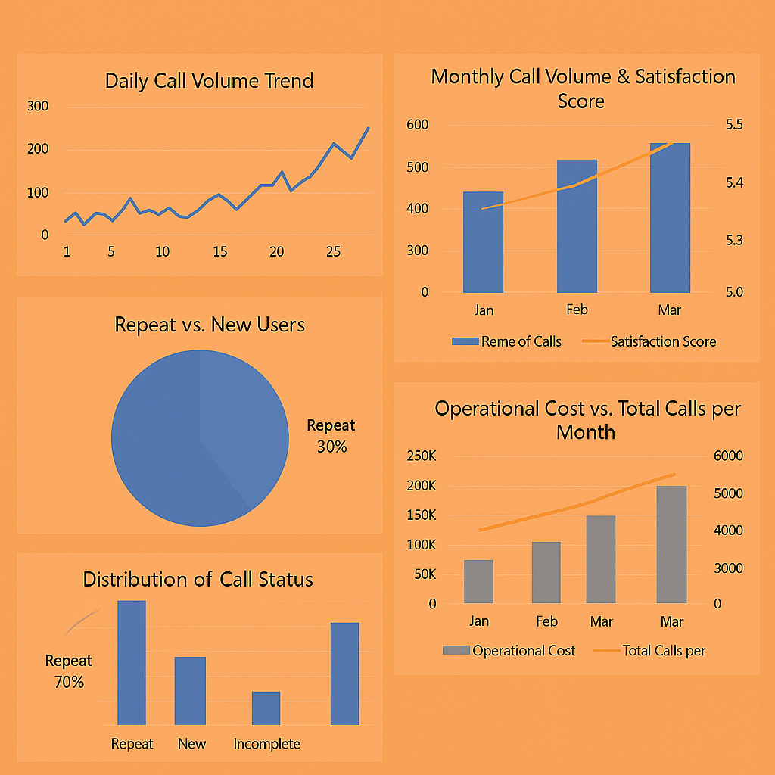 

 



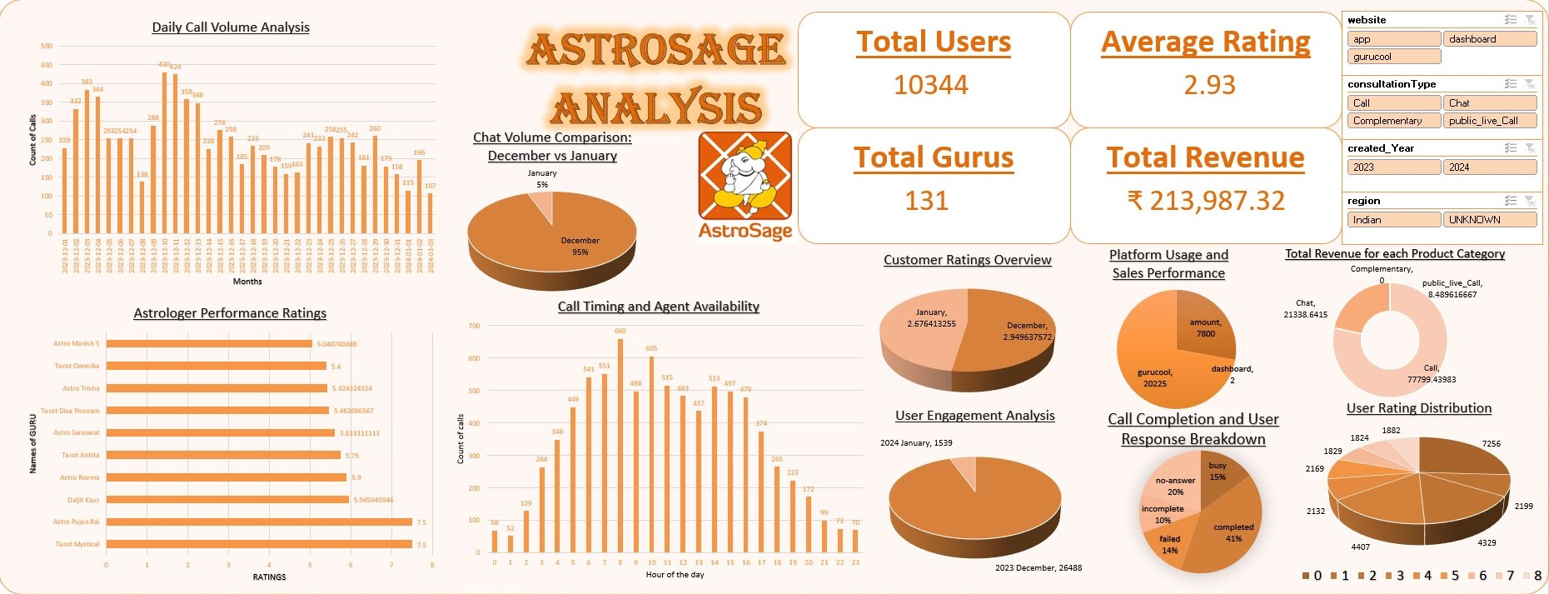

Thank you for showing your interest in my project and overviewing my project.

Hope I’m able to justify all the answers asked in the project.

LAKSHYA HASIJA